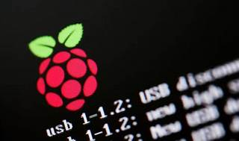

Explore

Certainly! In a nutshell, a **Raspberry Pi** is a series of **single-board computers** created by the **Raspberry Pi Foundation**. These tiny and affordable devices aim to **educate people in computing** and provide easier access to computing education. [They’ve been around since 2012 and have seen several iterations and variations1](https://opensource.com/resources/raspberry-pi).

Here are **five free resources** where you can learn more about Raspberry Pi:

1. [**Teach, Learn, and Make with Raspberry Pi**](https://www.raspberrypi.org/learn/): This official Raspberry Pi Foundation resource offers a wealth of tutorials, projects, and guides for both beginners and advanced users[2](https://www.raspberrypi.org/%20resources/).
2. [**Raspberry Pi Education Manual**](https://inventtolearn.com/resources-raspberry-pi/): A comprehensive guide for using Raspberry Pi in the classroom, covering topics like Python, Scratch, interfacing, and more[3](https://inventtolearn.com/resources-raspberry-pi/).
3. [**Opensource.com’s Raspberry Pi section**](https://opensource.com/resources/raspberry-pi): Explore articles, tutorials, and community-contributed content related to Raspberry Pi and its applications[1](https://opensource.com/resources/raspberry-pi).
4. [**How-To Geek’s Raspberry Pi Guide**](https://www.howtogeek.com/754492/what-is-raspberry-pi/): Dive into various aspects of Raspberry Pi, including its beginnings, different use cases, and advanced applications[4](https://www.howtogeek.com/754492/what-is-raspberry-pi/).
5. [**Free Raspberry Pi Courses**](https://coursesity.com/free-tutorials-learn/raspberry-pi): Access a collection of free courses from platforms like Udemy, Coursera, and YouTube to enhance your Raspberry Pi skills[5](https://coursesity.com/free-tutorials-learn/raspberry-pi).

Happy learning! 🌟🔍📚